Rising Waters: A Machine Learning Approach to Flood Prediction
Project Description:
One of the most critical natural disasters that significantly impacts human lives, infrastructure, agriculture, and the overall economy is flooding. Accurate flood prediction plays a vital role in minimizing damage and ensuring public safety. Early identification of flood-prone situations enables authorities to implement preventive measures, allocate resources effectively, and issue timely alerts. As climate variability increases, developing intelligent systems for flood risk evaluation has become increasingly important for disaster management and urban planning.
Flood prediction is a complex task because it depends on multiple environmental and climatic factors such as rainfall patterns, seasonal variations, temperature, humidity, and cloud cover. Traditional prediction methods often lack the ability to analyze large volumes of historical data efficiently. By leveraging Machine Learning techniques, patterns can be extracted from historical weather and rainfall data to predict the likelihood of severe floods. This helps in reducing potential losses, improving early warning systems, and strengthening disaster response planning.
In this project, we use classification algorithms such as Decision Tree, Random Forest, K-Nearest Neighbors (KNN), and XGBoost to build predictive models. The dataset is preprocessed, scaled, and split into training and testing sets for model evaluation. The best-performing model is selected based on accuracy, precision, recall, and confusion matrix analysis, and saved for deployment. The final model is integrated into a Flask web application and prepared for cloud deployment, enabling users to input environmental parameters and receive real-time flood risk predictions.
.

Technical Architecture:
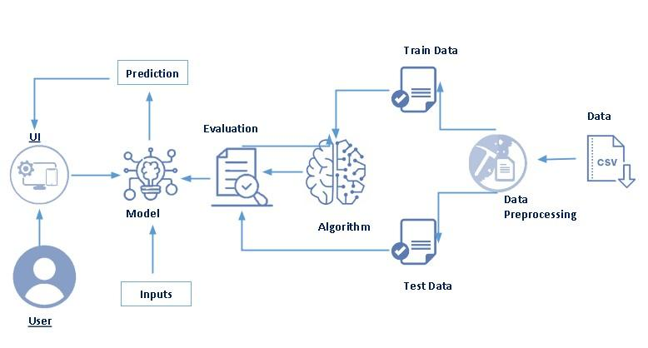

Prerequisites:
To complete this project, you must required following software’s, concepts and packages
- Anaconda navigator and pycharm:
  - Refer the link below to download anaconda navigator
  - Link : https://www.youtube.com/watch?v=5mDYijMfSzs
- Python packages:
  - Open anaconda prompt as administrator
  - Type “pip install numpy” and click enter.
  - Type “pip install pandas” and click enter.
  - Type “pip install scikit-learn” and click enter.
  - Type ”pip install matplotlib” and click enter.
  - Type ”pip install scipy” and click enter.
  - Type ”pip install pickle-mixin” and click enter.
  - Type ”pip install seaborn” and click enter.
  - Type “pip install Flask” and click enter.

Prior Knowledge:
You must have prior knowledge of following topics to complete this project.
- ML Concepts
  - Supervised learning: https://www.youtube.com/watch?v=QeKshry8pWQ
  - Unsupervised learning: https://youtu.be/D6gtZrsYi6c
  - Evaluation metrics: https://youtu.be/aWAnNHXIKww
- Flask Basics : https://www.youtube.com/watch?v=lj4I_CvBnt0

Project Objectives:

By the end of this project you will:
- Knowledge of Machine Learning Algorithms.
- Knowledge of Python Language with Machine Learning.
- You’ll be able to understand the problem to classify if it is a regression or a classification kind of problem.
- You will be able to know how to pre-process/clean the data using different data pre-processing techniques.
- Applying different algorithms according to the dataset and based on visualization.
- Real-Time Analysis of Project
- Building ease of User Interface (UI)
- Navigation of ideas towards other projects(creativeness)
- Knowledge of building ML models.
- How to build web applications using the Flask framework.

Project Flow:
- Install Required Libraries
- Data Collection
  - Collect the dataset or Create the dataset.
- Data Preprocessing
  - Import the Libraries.
  - Importing the dataset.
  - Understanding Data Type and Summary of features.
  - Take care of missing data.
  - Data Visualization.
  - Drop the column from DataFrame & replace the missing value.
  - Splitting the Dataset into Dependent and Independent variables.
  - Splitting Data into Train and Test.
- Model Building
  - Training and testing the model.
  - Evaluation of Model.
  - Saving the Model.
- Application Building
  - Create an HTML file.
  - Build a Python Code.
- Final UI
  - Dashboard of the flask app.

To accomplish this, we have to complete all the activities listed below:
- Data collection
  - Collect the dataset or create the dataset

- Visualizing and analyzing data
  - Univariate analysis
  - Bivariate analysis
  - Multivariate analysis
  - Descriptive analysis
- Data pre-processing
  - Checking for null values
  - Handling outlier
  - Handling categorical data
  - Splitting data into train and test
- Model building
  - Import the model building libraries
  - Initializing the model
  - Training and testing the model
  - Evaluating performance of model
  - Save the model
- Application Building
  - Create an HTML file
  - Build python code

Project Structure:

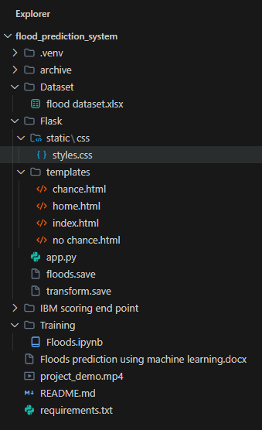
Create the Project folder which contains files as shown below
- We are building a Flask Application that needs HTML pages “home.html”, “index.html” stored in the templates folder and a python script app.py for server-side scripting
- The model is built in the notebook floods.ipynb
- We need the model which is saved and the saved model in this content is floods.save and transform.save
- The templates mainly used here are “home.html”, ”chance.html”, ”no chance.html”, “index.html” for showcasing the UI
- The flask app is denoted as app.py
- IBM scoring end point consist templates and app,py

Milestone 1: Data Collection
ML depends heavily on data, without data, it is impossible for an “AI” to learn. It is the most crucial aspect that makes algorithm training possible. In Machine Learning projects, we need a training data set. It is the actual data set used to train the model for performing various actions.
Activity 1: Download the dataset
- Download the dataset from the below link.
- There are many features that are responsible for predicting floods e.g. Annual rain fall, Cloud visibility, June-Sep rain fall etc.
- You can collect datasets from different open sources like kaggle.com, data.gov, UCI machine learning repository, etc.
- Here we are using a data set which you can find in the below link and you can download it from the
Link : Rainfall dataset
Milestone 2: Visualizing and analysing the data
As the dataset is downloaded. Let us read and understand the data properly with the help of some visualization techniques and some analyzing techniques.
Note: There is n number of techniques for understanding the data. But here we have used some of it. In an additional way, you can use multiple techniques.
Activity 1: Importing the libraries
- Import the necessary libraries as shown in the image. (optional) Here we have used visualization style as fivethirtyeight.

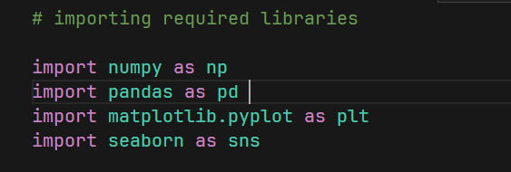
Activity 2: Read the Dataset
- Our dataset format might be in .csv, excel files, .txt, .json, etc. We can read the dataset with the help of pandas.
- In pandas we have a function called read_csv() to read the dataset. As a parameter we have to give the directory of csv file.

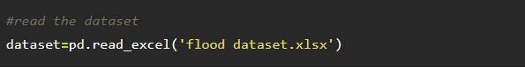
Activity 3: Univariate analysis
- In simple words, univariate analysis is understanding the data with single feature. Here we have displayed two different graphs such as distribution plot and box plot.
- Distribution plot:
  - The distribution plot is suitable for comparing range and distribution for groups of numerical data. Data are plotted as value points along an axis.
  - it is used to identify, what kind of distribution does the data follow.

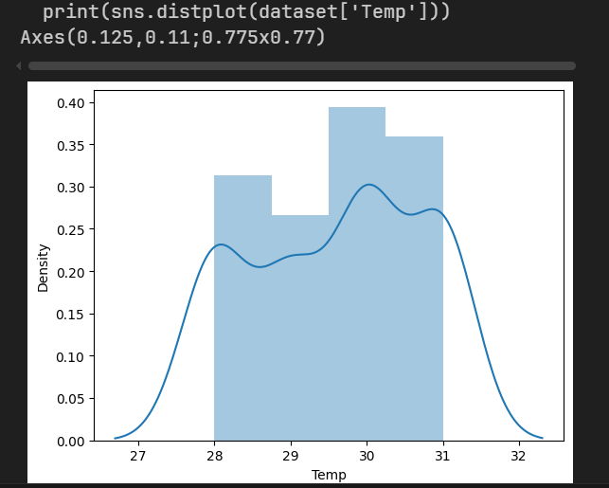
From the above graph, we can infer that the column temp follows some kind of normal distribution, it means the data is normal is almost normal.
- Boxplot:
  - Box plot is used on the length of service and average training score feature. Length of services feature has more outliers. The model should not be built without handling the outliers. Here, outliers are handled by the capping method. Capping will be discussed on data pre-processing.

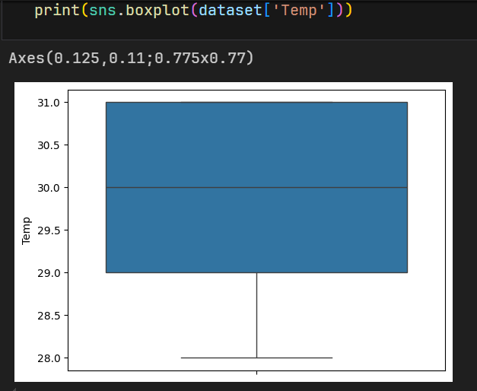

Activity 4: Multivariate analysis
In simple words, multivariate analysis is to find the relation between multiple features.
Heat map :
- A heat map is a data visualization technique that shows magnitude of a phenomenon as colour in two dimensions. The variation in colour may be by hue or intensity, giving obvious visual cues to the reader about how the phenomenon is clustered or varies over space.

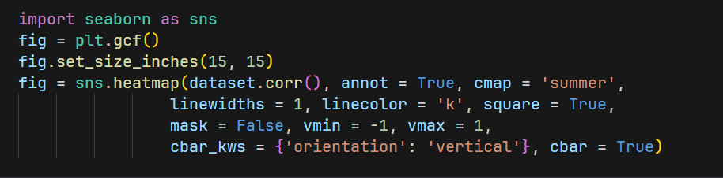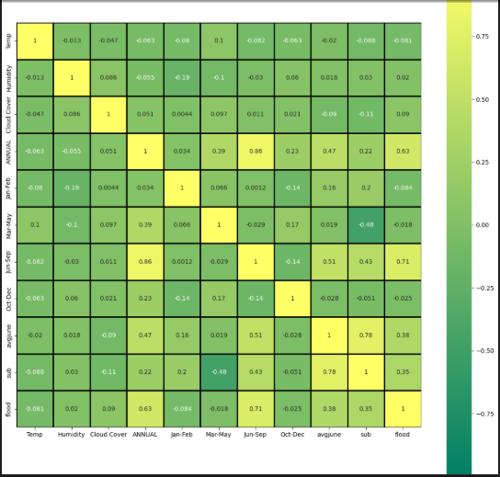

- From the above graph we can identify less correlated values and can drop those variables.

Activity 5: Descriptive analysis
To check the first five rows of the dataset, we have a function called head( ).
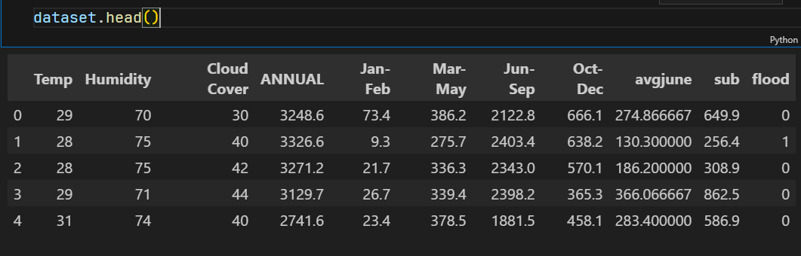

Understanding Data Type and Summary of features
- How the information is stored in a DataFrame or Python object affects what we can do with it and the outputs of calculations as well. There are two main types of data: numeric and text data types.
- Numeric data types include integers and floats.
- Text data type is known as Strings in Python, or Objects in Pandas. Strings can contain numbers and / or characters.
- For example, a string might be a word, a sentence, or several sentences.
- Will see how our dataset is, by using info() method.
- info() method provides the summary of dataset.

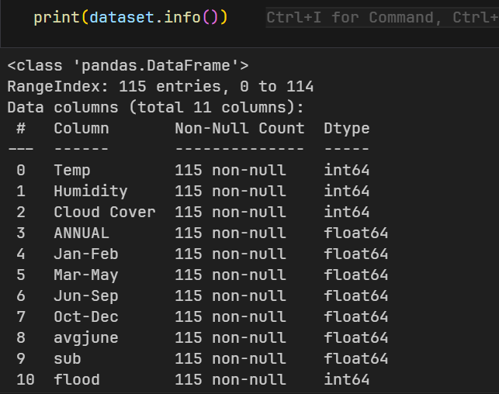

- As you can see in our dataset there is no textual data, all the set of data is in float and integer type.
- Describe () functions are used to compute values like count, mean, standard deviation give a summary type of data.

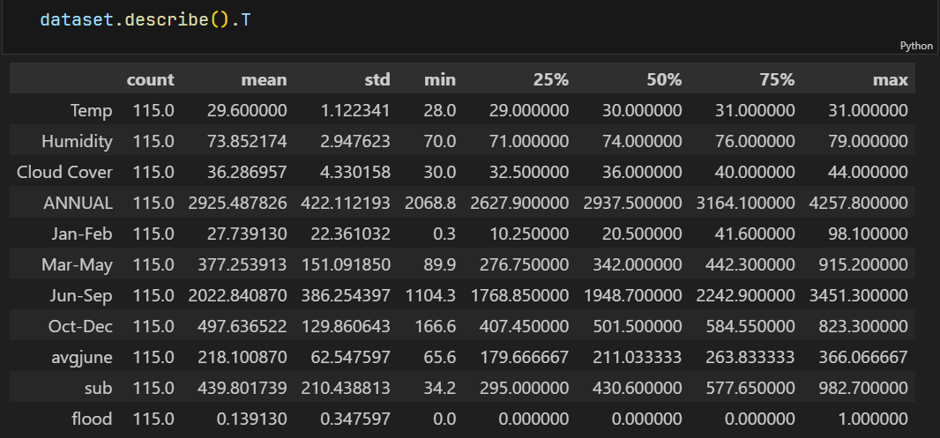
Milestone 3: Data Pre-processing
As we have understood how the data is lets pre-process the collected data.
The download data set is not suitable for training the machine learning model as it might have so much randomness so we need to clean the dataset properly in order to fetch good results. This activity includes the following steps.
- Handling missing values
- Handling categorical data
- Handling outliers
- Splitting the dependent and independent variables
- Splitting dataset into training and test set
- Feature scaling

Note: These are the general steps of pre-processing the data before using it for machine learning. Depending on the condition of your dataset, you may or may not have to go through all these steps.

Activity 1: Checking for null values
- Let’s find the shape of our dataset first, To find the shape of our data, df.shape method is used. To find the data type, df.info() function is used.

- Here the function is null.any() return the Boolean values False. When that return True, which means that particular in dataset has missing values. So we can skip this step

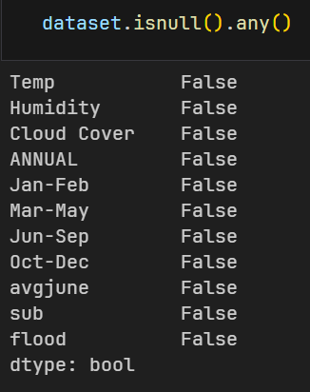

Activity 2: Handling Categorical Values
As we can see our dataset has categorical data we must convert the categorical data to integer encoding or binary encoding.
To convert the categorical features into numerical features we use encoding techniques. There are several techniques but in our project, we are using feature mapping and label encoding..

Note: In our dataset, there is no categorical data type, so we can skip this step.

Activity 3:Splitting the Dataset Into Dependent And Independent Vairables:
In machine learning, the concept of the dependent variable (y) and independent variables(x) is important to understand. Here, the Dependent variable is nothing but output in the dataset and the independent variable is all inputs in the dataset. We can denote with any symbol (alphabets). In our dataset, we can say that class is the dependent variable and all other columns are independent. But in order to select the independent columns, we will be selecting only those columns which are highly correlated and some value to our dependent column.
· With this in mind, we need to split our dataset into the matrix of independent variables and the vector or dependent variable. Mathematically, Vector is defined as a matrix that has just one column.
· Let’s create out independent and dependent variables:
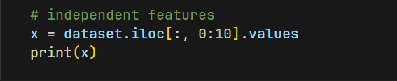
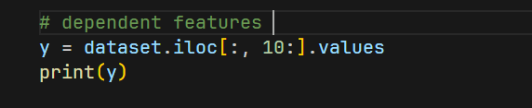
In the above code we are creating a DataFrame of the independent variable x with our selected columns and for the dependent variable y, we are only taking the class column.Where DataFrame is used to represent a table of data with rows and columns.
Activity 4: Split The Dataset Into Train Set And Test Set
- Now split our dataset into a train set and test using train_test_split class from sci-kit learn library.
- Train_test_split: used for splitting data arrays into training data and for testing data.

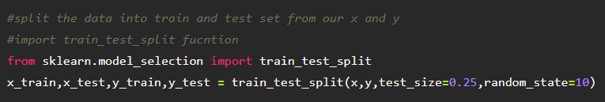

Activity 5: Feature Scaling
- Standard Scaler: Sklearn its main scaler, the StandardScaler, uses a strict definition of standardization to standardize data. It purely centers the data by using the following formula, where u is the mean and s is the standard deviation.
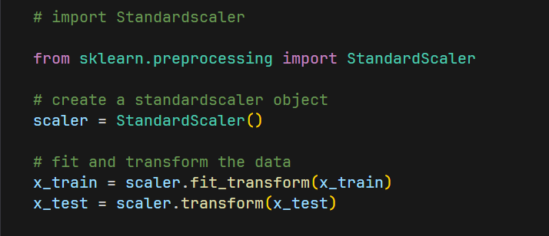
- Save the StandardScaler
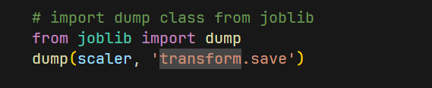

Milestone 4: Model Building
Now our data is cleaned and it’s time to build the model. We can train our data on different algorithms. For this project we are applying four classification algorithms. The best model is saved based on its performance. To evaluate the performance confusion matrix and classification report is used.

Activity 1: Decision tree model
A function named decision tree is created and train and test data are passed as the parameters. Inside the function, the DecisionTreeClassifier algorithm is initialized and training data is passed to the model with the .fit() function. Test data is predicted with the .predict() function and saved in a new variable. For evaluating the model, a confusion matrix and classification report are done.

Activity 2: Random forest model
A function named randomForest is created and train and test data are passed as the parameters. Inside the function, the RandomForestClassifier algorithm is initialized and training data is passed to the model with the .fit() function. Test data is predicted with the .predict() function and saved in a new variable. For evaluating the model, a confusion matrix and classification report are done.

Activity 3: KNN model
A function named KNN is created and train and test data are passed as the parameters. Inside the function, the KNeighborsClassifier algorithm is initialized and training data is passed to the model with the .fit() function. Test data is predicted with the .predict() function and saved in a new variable. For evaluating the model, a confusion matrix and classification report are done.

Activity 4: Xgboost model
A function named xgboost is created and train and test data are passed as the parameters. Inside the function, the GradientBoostingClassifier algorithm is initialized and training data is passed to the model with the .fit() function. Test data is predicted with the .predict() function and saved in a new variable. For evaluating the model, a confusion matrix and classification report are done.
Fit the model using x_train, y_train data
Now let’s see the performance of all the models and save the best model

Activity 5: Compare the model
For comparing the above four models compareModel function is defined.
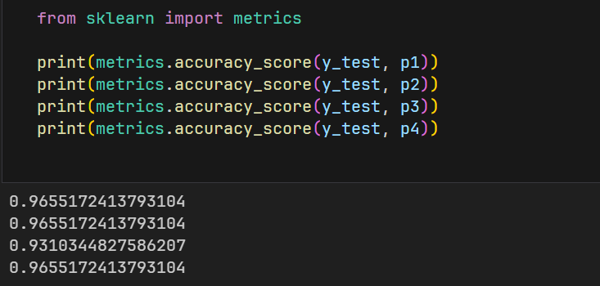
After calling the function, the results of models are displayed as output. From the four model Decision tree, random forest and xgboost are performing well. From the below image, we can see the accuracy of the models. All three models have 96.55% accuracy

Activity 6: Evaluating performance of the model
- After comparing all the three models with different attributes ,xgboost is the better model,so we will save this model

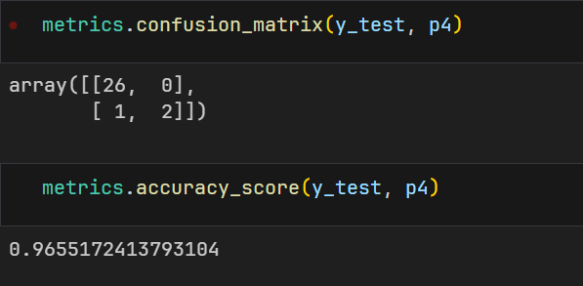
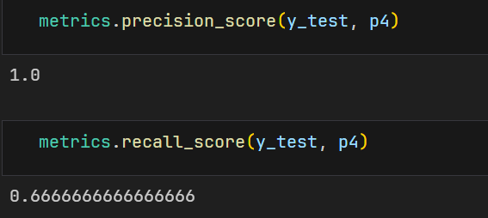

Activity 7: Saving the Model
- Joblib of save is used for serializing and de-serializing Python object structures, also called marshalling or flattening. Serialization refers to the process of converting an object in memory to a byte stream that can be stored on disk or sent over a network. Later on, this character stream can then be retrieved and de-serialized back to a Python object.
- Save our model by importing joblib dump class.

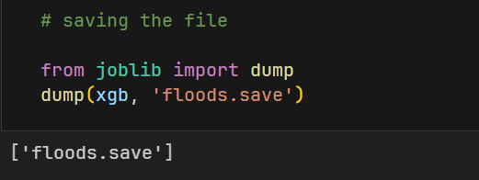
Here, xgb is our Xgboost Classifier with saving as floods. save file.

Milestone 5: Application Building
In this section, we will be building a web application that is integrated into the model we built. A UI is provided for the uses where he has to enter the values for predictions. The enter values are given to the saved model and prediction is showcased on the UI.
This section has the following tasks
- Building HTML Pages
- Building serverside script.

Activity1: Building Html Pages:
- Flask Frame Work with Machine Learning Model In this section we will be building a web application which is integrated to the model we built. An UI is provided for the uses where he has to enter the values for predictions. The enter values are given to the saved model and prediction is showcased on the UI.
- Previously we are saved this file as “floods.save”. We have 5 independent variables and one dependent variable for this model.
- To build this you should know the basics of “HTML, CSS, Bootstrap, flask framework and python” Create a project folder that should contain.
- A python file called app.py.
- Model file (floods.save).
- Templates folder which contains index.HTML file.
- Static folder which contains CSS folder which contains styles.css.
- We use HTML to create the front-end part of the web page.
- Here, we created 4 html pages- home.html, image.html, imageprediction.html, intro.html.
- We also use JavaScript-main.js and CSS-main.css to enhance our functionality and view of HTML pages.

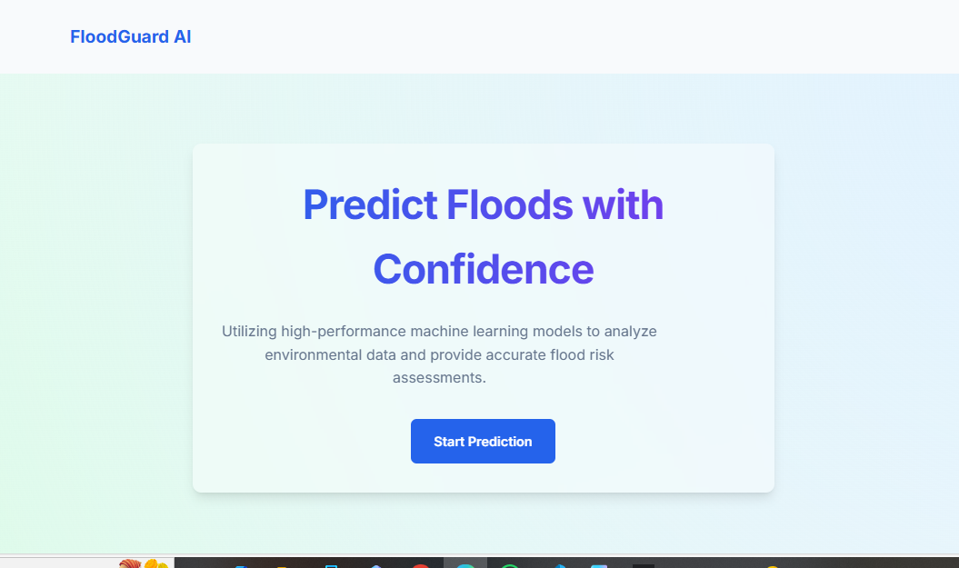
Now when you click on Start Prediction button you will get redirected to index.html
Lets look how our index.html file looks like:
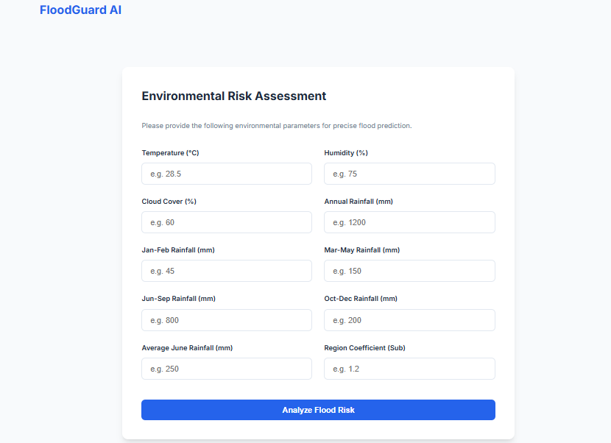

Activity 2: Build Python Code
- Let us build flask file ‘app.py’ which is a web framework written in python for server-side scripting. Let’s see step by step procedure for building the backend application.
- App starts running when “__name__” constructor is called in main.
- render_template is used to return HTML file.
- “GET” method is used to take input from the user.
- “POST” method is used to display the output to the user.
- We will be using python for server side scripting. Let’s see step by step process for writing backend code.
Importing Libraries
- Importing the flask module in the project is mandatory. An object of the Flask class is our WSGI application. Flask constructor takes the name of the current module (__name__) as argument Pickle library to load the model file.
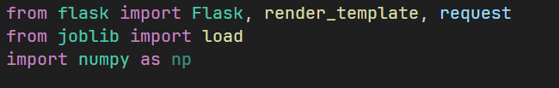
Create Flask app and Load our model file
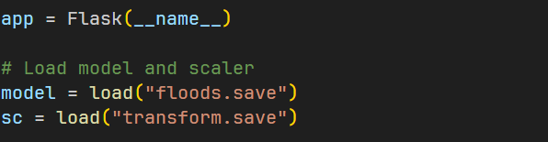
Routing to the HTML Page
- Here we will be using the declared constructor to route to the HTML page that we have created earlier.
- In the above example, the ‘/’ URL is bound with the home.html function. Hence, when the home page of the webserver is opened in the browser, the HTML page is rendered. Whenever you click on the Intro button from the home page, the intro.html page will be rendered.
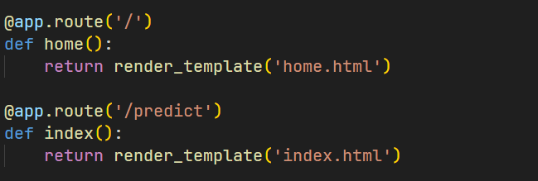
We are routing the app to the HTML templates which we want to render. Firstly we are rendering the “home.html” template which is the home page to our web UI. Where it will display two options, one is Home and Predict Floods.
When you click on Predict Floods, it redirects to the next page which is bounded with URL /predict. At that time index.html page will be rendered. Where to have to fill in all the details and get the result on the prediction page.
Route the prediction on UI
- predict() – is taking the values from the prediction page and storing it into a variable and then we are creating a DataFrame along with the values and 5 independent features and finally, we are predicting the values using or loaded model which we build and storing the output in a variable and returning it to the result page.
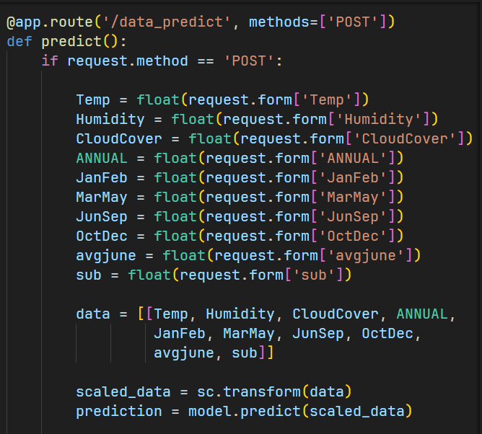
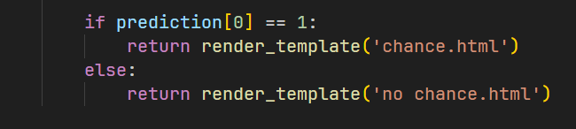
Main Function
- This is used to run the application in localhost
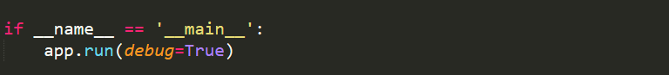

Activity 3: Run the application
- Open anaconda prompt from start menu.
- Navigate to the folder where your app.py resides.
- Now type the “python app.py” command.
- It will show the local host where your app is running on http://127.0.0.1.5000/
- Copy that local host URL and open that URL in browser. It does navigate you to the where you can view your web page.
- Enter the values, click on predict button and see the result/predict on web page.

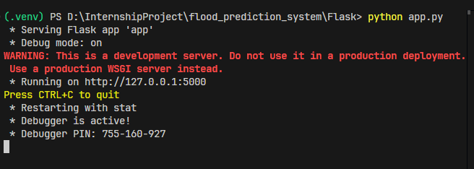

Navigate to the localhost (http://127.0.0.1:5000/) where you can view your web page.
Click on Predict Floods and submit the values to get the floods prediction result on the web page.

Output:
- This is the home page of floods prediction.

Then Click on the Start Prediction which redirect to the prediction page, user gives the input for predicting the output where they can give input as Cloud visibility, Annual Rainfall, some other inputs, then click to submit the output

- On the prediction page, users will get the output based on the inputs they give on the prediction page.

Output 1:

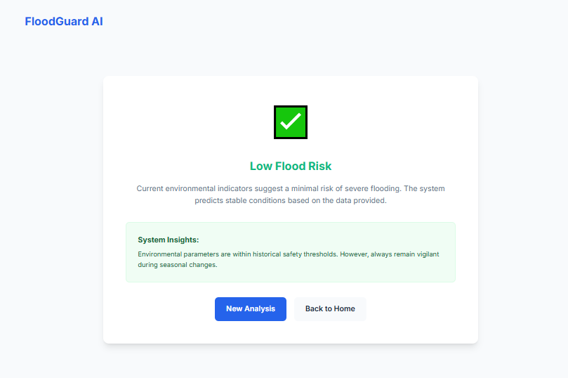

Output 2:

